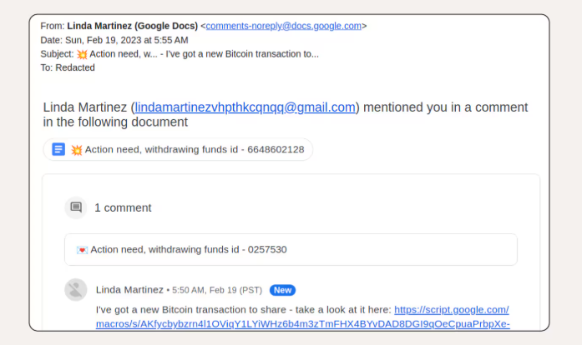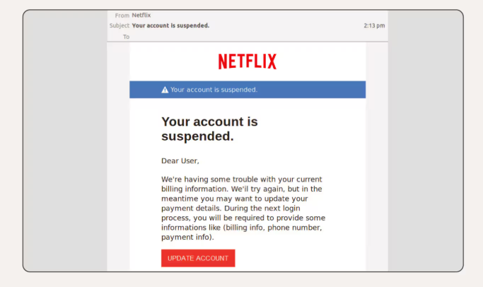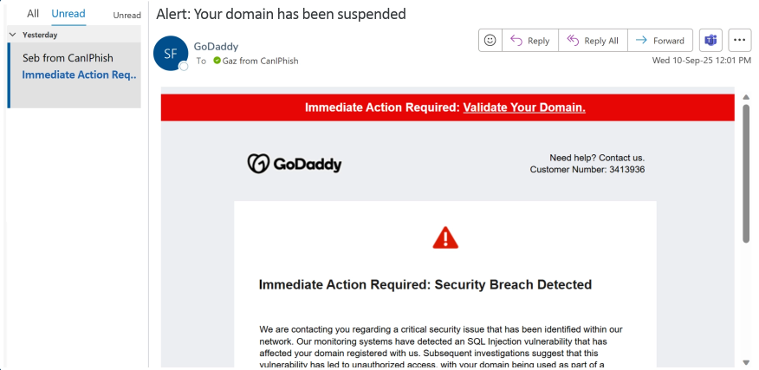phishing email screenshot 1:

This Google Docs phishing scam contains a link from an unknown contact, is addressed to “Redacted,” implies urgency, and the sender’s email address in the copy of the email looks suspicious.

phishing email screenshot 2:

There are spelling and grammar mistakes throughout the email. The customer's name is missing from the greeting and the “To:” field is completely blank, meaning the email was likely part of a larger phishing campaign sent to multiple email addresses.

phishing email screenshot 3
The email is confronting right away, with a red warning banner and alert icon grabbing your attention. It uses technical terms like “SQL Injection” and “botnet” to sound credible and serious. Phrases like “critical issue” and “illegal activity” ramp up fear and urgency, pushing recipients to act before thinking clearly.

